

In partnership with



Weedon New Town Redevelopment Plan

A new era for Daventry District

**Next review due:** 24th July 2021

**Published by:** Local Revamp England and Sustainable Transport Northamptonshire

**Written by:** Harry Burr, on behalf of Local Revamp England

**Helpful link:** [Our interactive map](https://www.google.com/maps/d/u/0/edit?mid=1k6LSd4y3bquxALrCe3_43heLnnW4WQLX&usp=sharing) (<https://www.google.com/maps/d/u/0/edit?mid=1k6LSd4y3bquxALrCe3_43heLnnW4WQLX&usp=sharing>)

Contents:

1. The new town/village relationship
   1. Weedon Bec and Weedon will be separate
   2. Where we have touched within Weedon Bec
   3. The Depot: In Weedon Town or Weedon Bec?
   4. Weedon Town’s new name
2. A new Community Council
   1. Why a new parish council?
   2. Are we keeping Weedon Bec PC?
   3. Where will the new CC cover?
   4. New town hall
   5. New Community Council building
3. Our proposed changes
   1. High Street
      1. New businesses
      2. Access to canal
      3. Local Council Hub
      4. Community Council Building
   2. New Town Centre
      1. New greenery, trees, and nature
      2. Coffee shop
      3. Takeaway
      4. Relocating existing businesses from here
      5. Buildings that will sink in with the new green landscape
   3. Parking
      1. Station/Central Parking
      2. East Parking
   4. New mini retail park
   5. The Depot
   6. Housing
      1. Commuter-focussed new housing
      2. Western housing estate
      3. Eastern housing estate
   7. Transport links
      1. Rail
      2. Bus
   8. Pedestrian changes
      1. New paths
      2. New canal entrances
   9. The canal
      1. Making it a tourist attraction
      2. Concrete layer
      3. Shops and cafes
      4. New canal entrances
      5. New bridge
      6. Upgraded bridge near High Street
   10. Flood defence
       1. River Nene: Prone to flooding
       2. Old Mill Race
       3. Locations of defences
   11. Two new supermarkets
       1. Budget supermarket
       2. One of the Big Five
   12. New educational institution (primary)
       1. Why
       2. Safety
   13. Misc.
       1. Town hall
       2. Food bank
       3. Police station/fire station combination
       4. Doctors surgery
   14. Relocating businesses
       1. On the High Street
       2. Relocating where?
          1. New mini retail park
          2. Depot
          3. Town Centre
          4. Weedon Riverside station
4. Just a concept
   1. Could be approved, could not
   2. Businesses shall not worry
5. Positives of this plan
   1. Increasing population
   2. Boosting the economy
   3. Another town in Northants (we do not have many)
   4. Transport links for Daventry
6. Problems with this plan
   1. Residents might not like it
   2. Leaving Weedon Bec alone
   3. Traffic congestion
   4. Might get cramped

# 1. The new town/village relationship

## Weedon Bec and Weedon will be separate

Weedon Bec is different to the new Weedon Town concept, it has heritage, and residents who live there because of that heritage and the rural-ness of it all. Building a massive town on top of all of that may not be liked by some residents. We are respecting their view and avoiding new development in the village of Upper Weedon itself.

## Where we have touched Weedon Bec

However, we have had to touch Upper Weedon a little bit, to enable changes in the new Weedon Town. For example, The Depot, which is a new development from an old disused army barracks could be counted as in Upper Weedon, however, we are modifying it and making changes. As well as this, we are constructing a new entrance to the canal within Upper Weedon, which will connect to the new Weedon Town. This should not be a massive issue with the Weedon Bec residents.

## The Depot: In Weedon Town or Weedon Bec?

This leads us on great to the next section, is The Depot in Weedon Town or Weedon Bec. I think for the sake of this concept, it needs to be in Weedon Town, as we will be redeveloping it significantly. The new boundary for Weedon Town will be in this case everywhere North of The Depot development. More on this later.

## Weedon Town’s new name

Before I continue, let us get something straight with the town's new name. We have a few options such as just Weedon, but it might get confused with Weedon Bec, which is normally shortened to just that. A name such as Weedon Garden Village is long, and sounds like a shopping village, which is not what we want. Something like Weedon Riverside (which it is), could be chosen, but I have come up with the following final options:

1. Weedon Riverside
2. Weedon Town
3. Lower Weedon
4. Weedon Garden City

So, here is how we came up with the final decision:

1. Weedon Riverside

It is a fact, Weedon is on the River Nene. The name sounds modern and reflects some of our heritage with being on the Nene.

2. Weedon Town

My first reaction: Sounds like a football team… something I did not want it to get mixed up with. When I first thought of the idea, I discarded it, so this idea will not be going ahead.

3. Lower Weedon

Currently the way of splitting Weedon Bec into two is Lower and Upper Weedon, Lower being the area with Tesco in it, and Upper being the area with One Stop in it (I know, an interesting way of differentiating the two). I was not a big fan of this name. Sounds old.

4. Weedon Garden City

Oh no no no, this new town is not a city. I discarded this idea too.

So, my final option was **Weedon Riverside**, which I was more than happy with. A modern, snappy, factual name. For the remainder of the document, we will be referring to the new town as Weedon Riverside.

# 2. A new community council

## Why a new parish council?

A new parish council is vital due to the expected population increase in the new Weedon Riverside town. This will come in the form of Weedon Riverside Community Council, performing the same operations as a Town Council would, just through a different name.

## Are we keeping Weedon Bec PC?

Yes, of course we will. The residents of Upper Weedon still need a say in their local community, so Weedon Bec Parish Council will still exist to serve them, and everywhere South of The Depot, where, unless it was for WBPC, would be unparished.

## Where will the new CC cover?

The new Weedon Riverside Community Council will cover as South as The Depot to as North as the terminating area of the new concrete layer for the canal towpath (more on this later), however, within the part of Upper Weedon the new CC will control, the Parish Council can still have responsibilities in partnership with the new Weedon Riverside CC.

## New town hall

The new town hall will be based in the Eastern end of Weedon Riverside, near a new flood defence and food bank. People can go here for advice and support, and hire it out for events, however...

## New Community Council building

...A new Community Council building will also exist in the High Street, right opposite a new Local Council Hub for West Northamptonshire Council. They will be extremely tied into each other, and the new Community Council building will be made specifically for the following:

* A new co-working space
* A virtual address service for Weedon Riverside businesses
* Advice and support for residents
* Weedon Riverside CC and other organisation meetings

# 3. Our proposed changes

## High Street

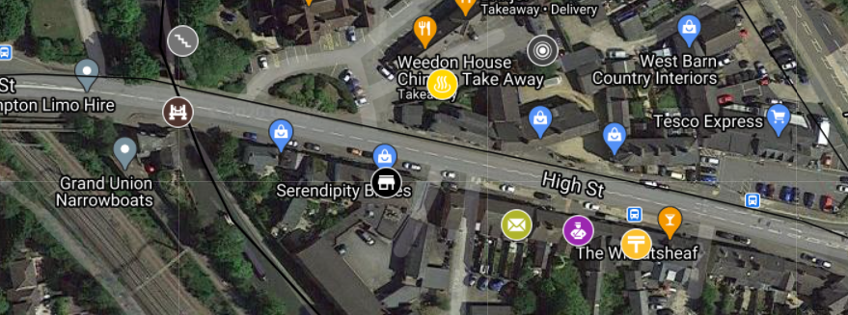

### New businesses:

New businesses will of course be implemented on the high street. These include a new Post Office, replacing the one that was closed around one year ago, allowing services such as post collection and drop off, PO boxes, and cash withdrawal, bank account management.



The store “Serendipity Brides” is recommended to relocate, to free up space for one of the following:



* A new bank, such as Nationwide or HSBC. A survey within the town could be held on this choice.
* A new charity shop, something that is present at almost every proper British town in the country, I would say.
* A chain shop such as a Wilko or Argos. A quick note on Argos, another one of our plans is to implement a supermarket on the outskirts of Weedon Riverside, and if this supermarket turns out to be a Sainsbury’s, an Argos branch will be present inside it.

Many businesses will be implemented at the new Town Centre central area, which I will get onto a bit more later.

### Access to canal:



As part of this project, a lot will be done to refine access to the canal from many locations in Weedon Riverside, with one of the refined entrances being from the High Street, right now a set of stairs that are neglected, meaning unsafe, slippery and not accessibility friendly. A new accessible entrance will be constructed, including a new ramp and stairs, to enable anyone to get to canal level. There will be a lot more on all these refinements later.

### Local Council Hub Building:



At the old "Apple Village" store, a new Local Council Hub, a first of its kind in the county, will be built, to allow residents fast access to Unitary council services from the West Northamptonshire Council, such as advice and support on housing, tax, and planning permission, instead of having to go all the way to Northampton.

### Community Council Building:



Conveniently right opposite this new Local Council Hub building will be, as I wrote about earlier, a Community Council Building:

“A new Community Council building will also exist in the High Street, right opposite a new Local Council Hub for West Northamptonshire Council. They will be extremely tied into each other, and the new Community Council building will be made specifically for the following:

* A new co-working space
* A virtual address service for Weedon Riverside businesses
* Advice and support for residents
* Weedon Riverside CC and other organisation meetings”

## New Town Centre

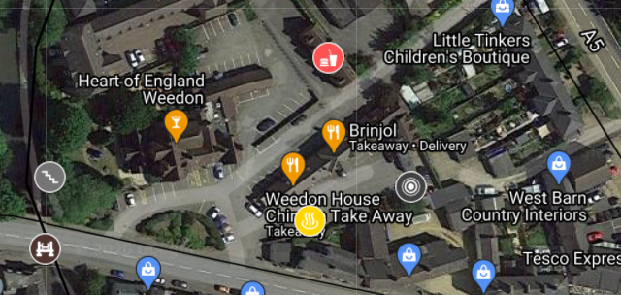

### New greenery, trees, and nature



A new town centre will be implemented, and not only a place to shop, but also a place to relax and take in the green scenery which will be artificially added to the area, to provide somewhere people can go to take a breather, with benches

### Coffee shop



Currently something Weedon lacks is a coffee shop, just two Costa Expresses, and a Starbucks at a newly built motorway junction services around a 5-minute drive away. I am certain this is something the Weedon Riverside people will want, and possibly even need, especially if they are a commuter. More specifically, this will be a Costa or Starbucks franchise, something dear to most Britons hearts.

### Takeaway



Now, Weedon is also lacking a nearby chain takeaway. As more young adults will live in the area to commute to London, Birmingham, Coventry etc. a new Subway/Dominoes/McDonald's type takeaway service could be implemented here, not only allowing eat in/takeaway, but also a delivery service.

### Relocating existing businesses from here

Businesses already exist in this area, and three of them, and possibly five of them will have to move, according to our diagram:

* Weedon House Chinese Take Away
* Brinjal
* Helios & Co (Antiques)
* **Possibly**
  + West Barn Country Interiors
  + The Rose Wardrobe

These businesses can be relocated to one of many new available spaces at Weedon Riverside. More will be mentioned on this topic later in the document.

### Buildings that will sink in with the new green landscape

### All the new businesses will be required to follow a strict new architecture policy in the Town Centre central area, with a modern wood-feel design, mixing in with the green vibe of the new central area.

## Parking

### Station/central parking:



A new two-story parking area will be located near the station, acting as parking for the station and the high street. The Sustainable Transport Northamptonshire Daventry Parkway branch will be making a comment on this shortly.

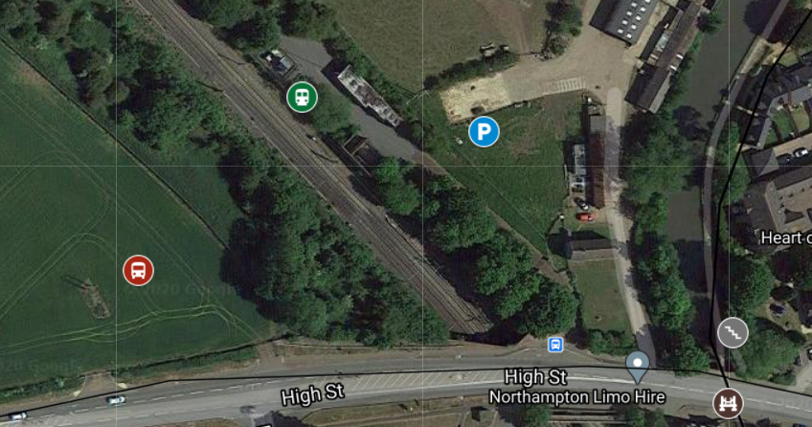

The new parking facility will be the largest in Weedon Riverside, to serve the area with the most demand, most likely.



**Comment:**

This new parking facility will not only act as a gateway to Weedon Riverside High Street and Town Centre, but also for the new Weedon Riverside / Daventry Parkway station. It will also not only enable a park and ride system, but also a new “Charge and Ride” system, allowing London Northwestern Railway passengers to charge their car while on the train. With the Weedon Riverside new town project as well, this could enable a “Charge and Visit” service too. Just drive your EV to Weedon Riverside, plug in, and walk around High Street, the converted Depot, the newly redeveloped canal area, and what have you.

### East parking



Parking will also exist towards the South East of the Weedon Riverside boundary, near a new flood defence wall, and mini retail park.

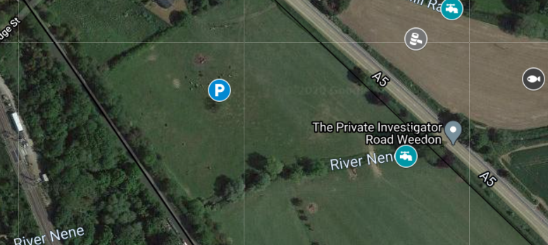

This will also include a “Charge and Visit” service, as Sustainable Transport Northamptonshire said in their comment, and will also join up to a new pedestrian footpath going from the new retail park to the station, high street, and the canal. This new East car park can also act as a secondary buffer car park for the station. More on the pedestrian situation later.

## New mini retail park



A new retail park will be formed and constructed at the South East of Weedon Riverside, available for new local businesses and larger companies that want to settle in Weedon. In my vision, it should be relatively small and “quaint”, you could say. It will allow space for businesses that move from the high street, too. The new “mini retail park” will be around a 2-minute walk from East parking and will be linked to the new pedestrian footpath going from this retail park to the High Street and Canal.

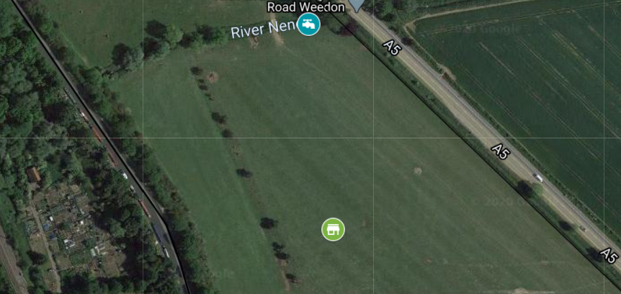

## The Depot

We currently have no comments about the development of The Depot in Upper Weedon, therefore will not add any in this section. Dated Thursday 24th December 2020.

## Housing

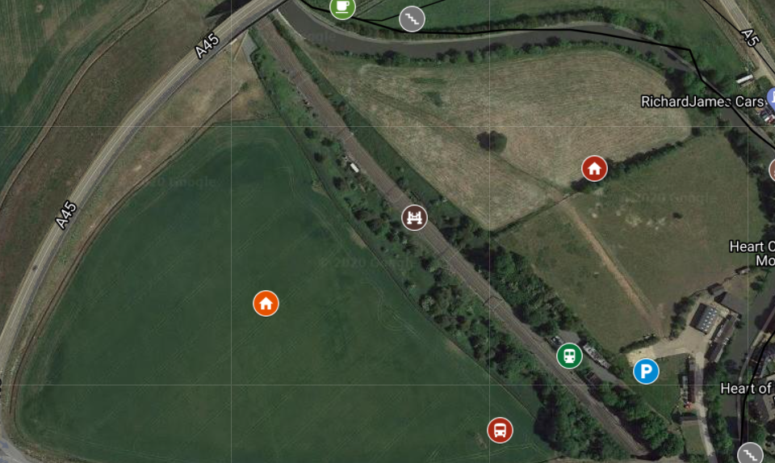

### Commuter-focussed new housing

As Weedon Riverside will be a commuter focussed town, you could say, our housing will all be relatively close to Weedon Riverside / Daventry Parkway station. Sustainable Transport Northamptonshire do have a brief comment on this. Both housing estates will be connected to each other via a railway bridge, and could be counted as one medium to large sized housing estate





**Comment:**

Housing near Weedon Riverside station would be totally valuable for the project, allowing these houses to sell in record time, due to the super impressive transport links bought in by the new Weedon Riverside / Daventry Parkway project.

### Western housing estate



The first estate we should cover is the Western housing estate, and as the name suggests, it is located to the West of the West Coast Main Line and Weedon Riverside station. There is space for around 50 houses in the estate (give or take), according to average data on other housing projects in the area.

### Eastern housing estate



Of course, this is the equivalent housing estate, but to the East side. Not much else to say about it, except there is also space for around 50 houses (give or take), according to average data on other housing projects in the area, and will be a dream for city commuters who travel via rail to live in.

## Transport links



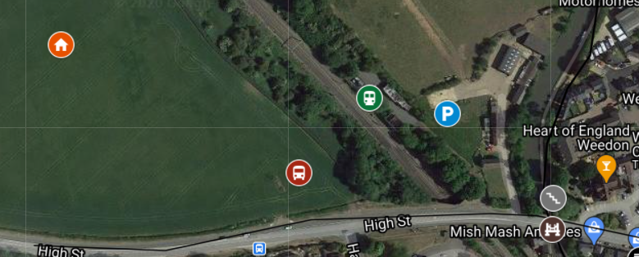

### Rail



This brings us on well to our next topic, rail. By the way, this is written by Sustainable Transport Northamptonshire, as is everything in the “Transport Links” section. With every place comes demand for transport, and this is not an exception here. Rail is one of the most popular modes of transport in the country.

Weedon Station Project is Sustainable Transport Holding’s most popular project to date, made to reconnect Lower and Upper Weedon, Daventry, and the surrounding villages to rail again, serving mainly as a Daventry Parkway station. If this new Weedon Riverside project gets approved however, it will not act as much as a Daventry Parkway station, but instead will act as a Weedon Riverside station itself, being at the centre of the town, which makes a change for many towns like Weedon Riverside.

### Bus



Bus is one of the worst transport links in the county now (Dec 2020) (rail coming first, of course). This is a way to change that. A new bus station/terminal will be implemented outside Weedon Riverside station, allowing quick and easy changes onto bus services for nearby villages/bus stops within Weedon Riverside, and being a central area to implement a bus station within the new town.

## Pedestrian changes

### New paths

Two new pedestrian footpaths will be implemented in Weedon Riverside.

1. **A new footpath going from the new “mini retail park” in the South, to the station and Eastern housing estate in the North West**  
   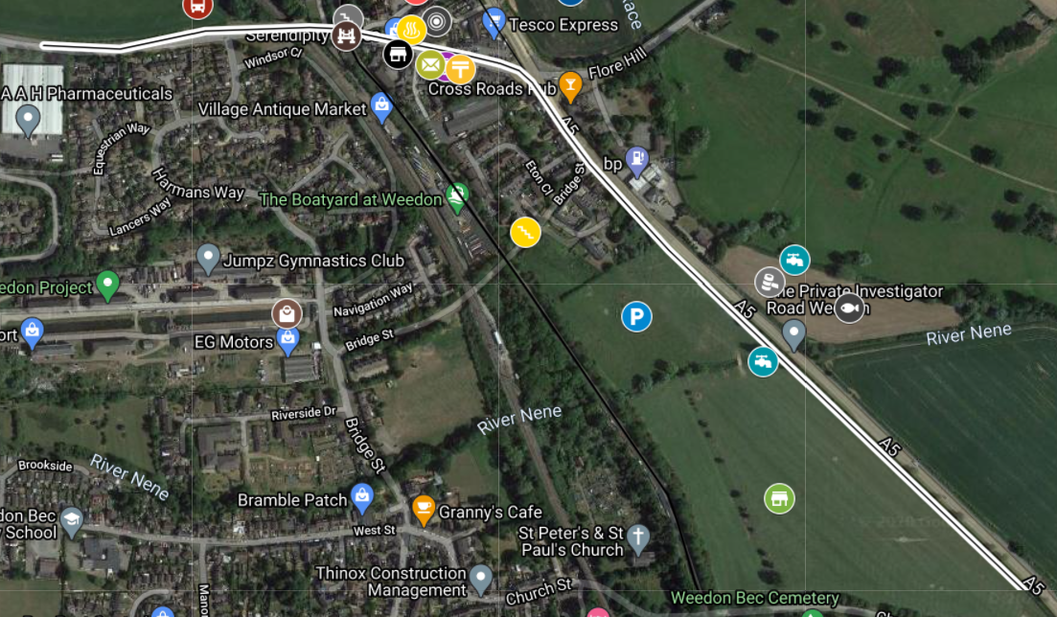
2. **A part of this path branches off at the Crossroads pub, to the new cafe and entrance to the canal in the North. More on this later.**  
   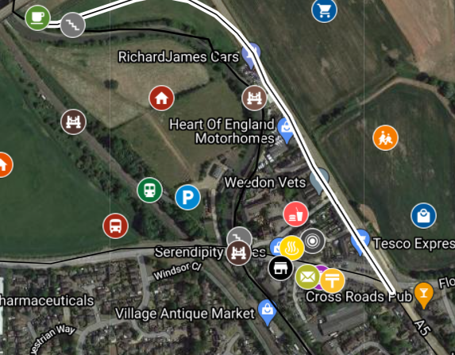

### New canal entrances

Especially important in our new redevelopment plan for Weedon Riverside is the canal, acting as a tourist attraction for the town. To allow quick, easy, safe, and accessible access, more than three new entrances to the canal will be implemented, all with ramps and stairs. The canal footpath within the Weedon Riverside Urban Area will also have a concrete layer, making biking and wheelchairs more friendly to the canal. That brings us on well to our next topic.

## The canal

### Making it a tourist attraction

As I mentioned just now, we’d like the canal to be at the centre of Weedon Riverside, being its main tourist attraction. To stick to this promise, we need to make sure the canal is pleasant to visit and walk around, which is why we will be developing the area significantly, which I will detail right now.

### Concrete layer

Something many villages and towns that are based around the canal have done, such as Stoke Bruerne, is implementing concrete on their paths to make them more friendly to bikers and wheelchairs.

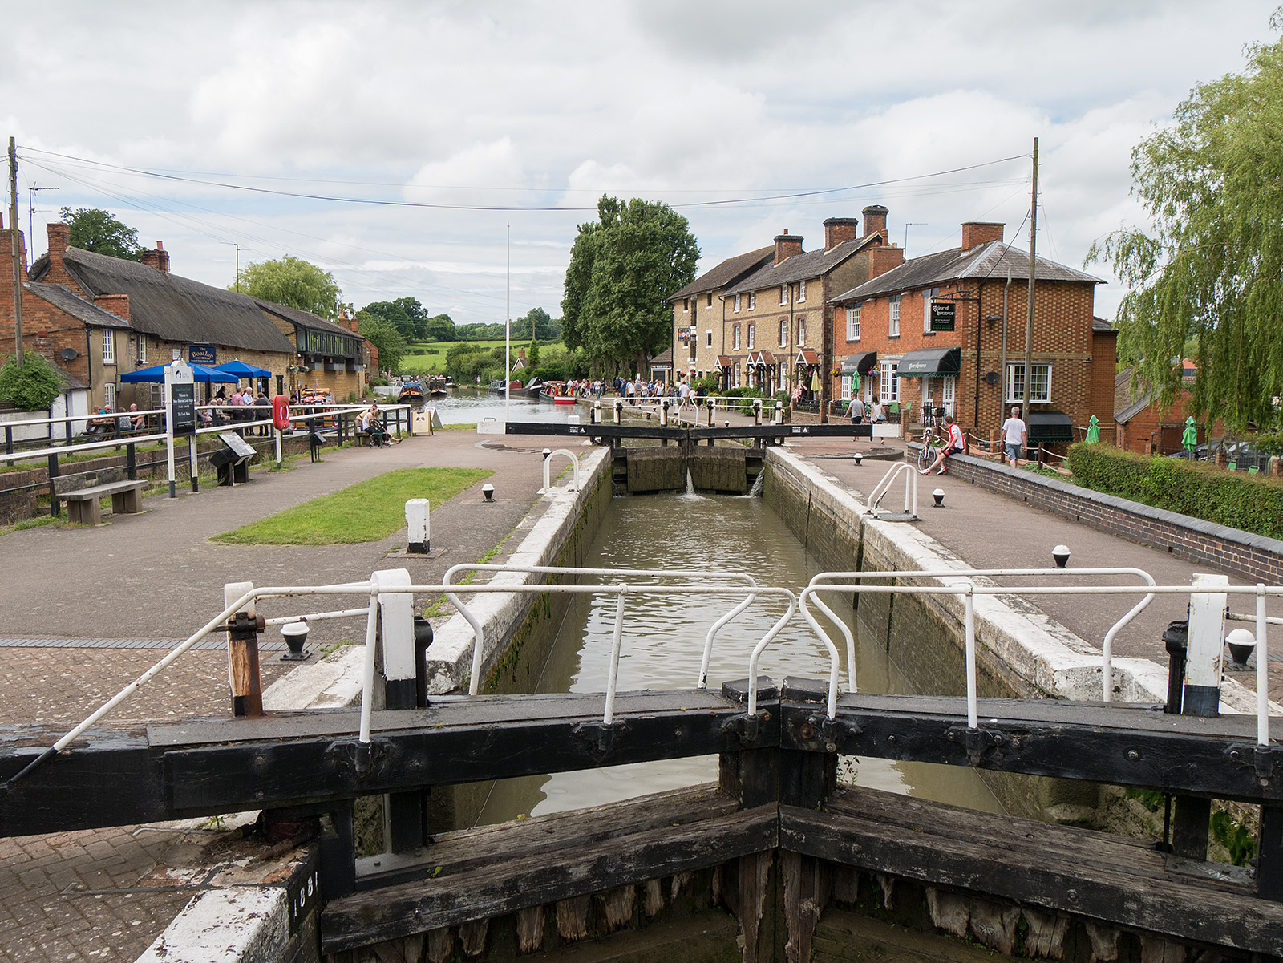

As well as making it more friendly to bikers and wheelchairs, it also makes them more aesthetically pleasing, instead of soggy, wet, squidgy mud. Yeah, it makes you uncomfortable just thinking about it, doesn’t it? On the interactive map, you can see the rough path I have drawn from where the area of the footpath that will have a concrete layer will start and end.

### Shops and cafes



Something also implemented in Stoke Bruerne are shops and restaurants along the canal, such as The Navigation, a Chinese restaurant, and even a canal museum run by the not for profit that manages the canals, Canal and River Trust. This is 100% an idea I would like to borrow for Weedon Riverside.

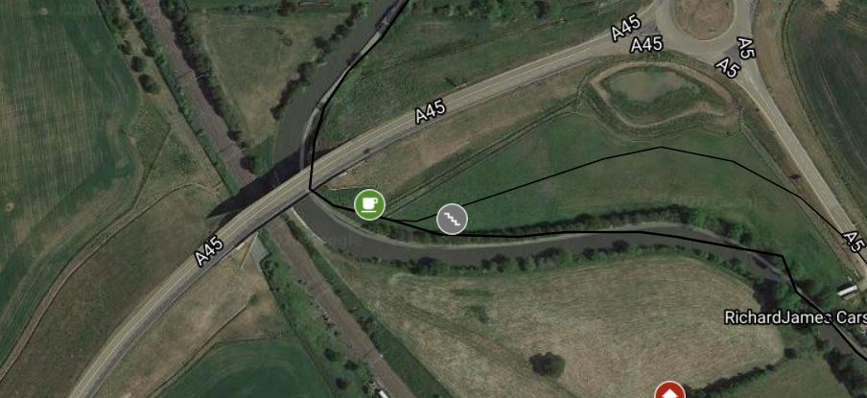

As it says on our map: “Area with a locally owned coffee shop/ice cream shop etc with a cafe (could be a Costa or Starbucks chain) so walkers/bikers/joggers can stop off to get some refreshments.”

In my opinion, this is a great idea, attracting more business to the area. Think about it, a, for example, Coventry resident, going out on their bike for the day to get out the hustle and bustle of the city:

1. Buys his train ticket, takes his train
2. Arrives in Weedon Riverside, buys himself a coffee from the Town Centre
3. Wanders around some of the shops, buys some food from the new supermarket
4. Goes for a bike ride
5. Stops at this new cafe for an ice cream and coffee
6. Rides back to the station, train is delayed, let’s say (hopefully that won’t happen!)
7. Instead, goes for a meal at a new restaurant
8. Train arrives, leaves back for Coventry, pays for the train ticket back.

How much did that just add to the local economy? Quite a lot.

As you can see on the map screen capture above, there is also a new entrance to the canal, via the path I mentioned in the “Pedestrian changes” section I wrote:

“A part of this path branches off at the Crossroads pub, to the new cafe and entrance to the canal in the North…”

### New canal entrances



This brings me well onto our next section, the new entrances to the canal at Weedon Riverside. In total, there are two that will be refurbished, and around seven that are designed to be used in the Weedon Riverside Urban Area in total, that are incredibly old. Two of them, the High Street entrance, and the Cafe entrance, will be revamped for easy accessibility for bikers, wheelchairs, and of course, standard pedestrians.

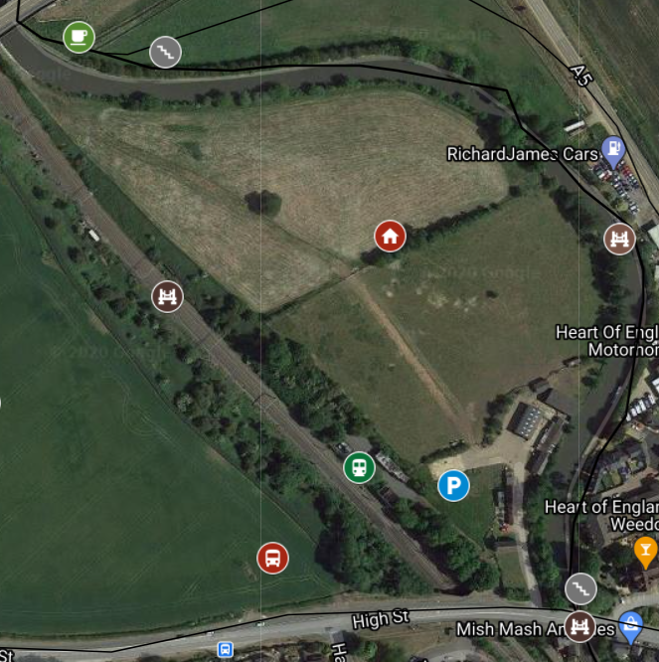

You can spot these two revamped ones on this map, at the bottom right and top left.

### New bridge



Just a quick short section to make you aware of a new pedestrian canal bridge connecting Western Housing Estate to the A5 pedestrian path, to allow access to the new school and new supermarket(s).

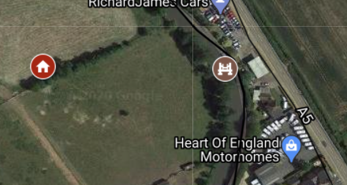

### Upgraded bridge near High Street



Now, these double bridges are in dire need of some reconstruction, to make them look more modern and stable from underneath, to add to the new canal redevelopment for the town.

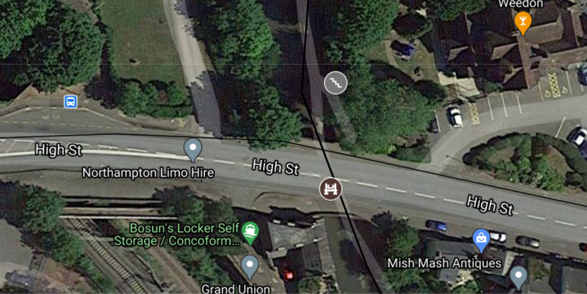

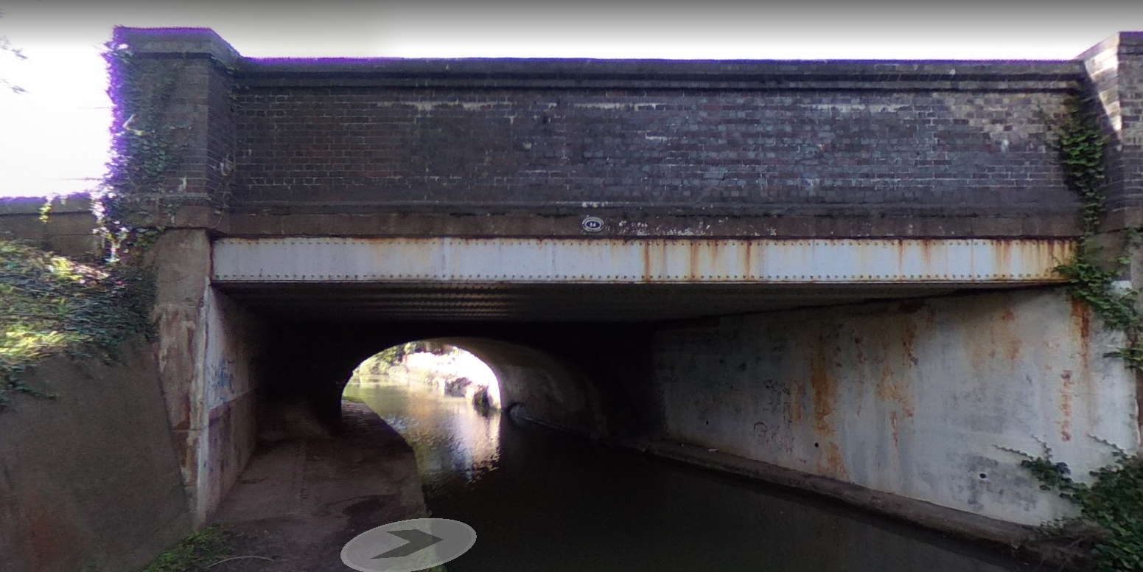

As you can see, they currently look unstable, old, dodgy, and not a nice thing to walk under. While proposed renewal works take place, the High Street road along this area may have to be shut, with traffic diverting through Weedon Bec village as opposed to Weedon Riverside.

## Flood defence

### River Nene: Prone to flooding

I do not think there is any need to add any context, but here are some photos to prove my point (Dec 2020, jplMedia, Northampton City Centre)

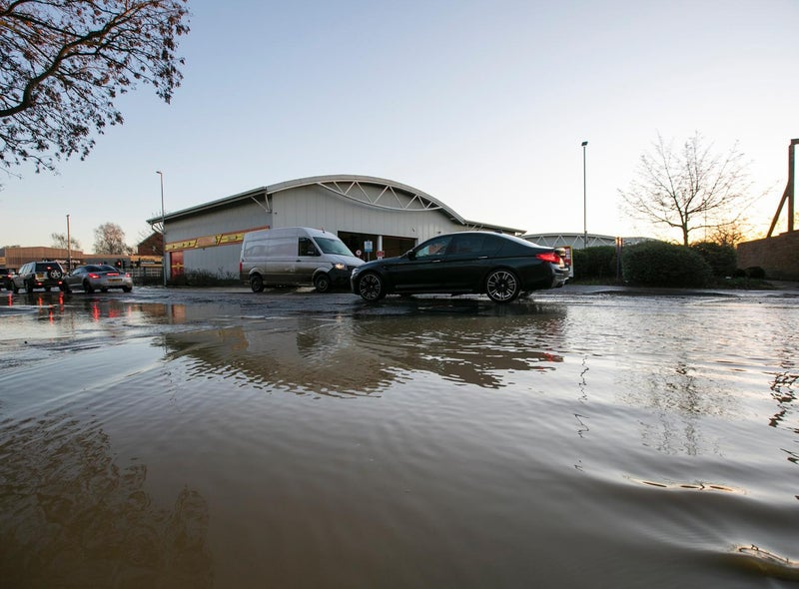

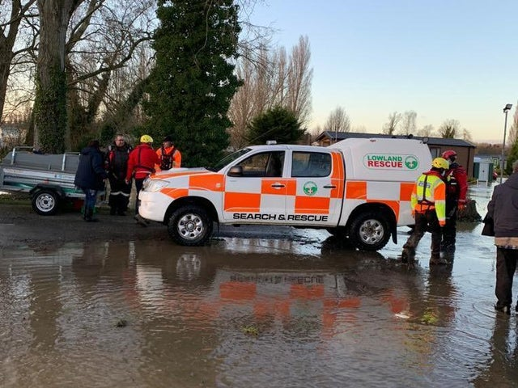

**"This is an exceptionally challenging situation," says police chief**

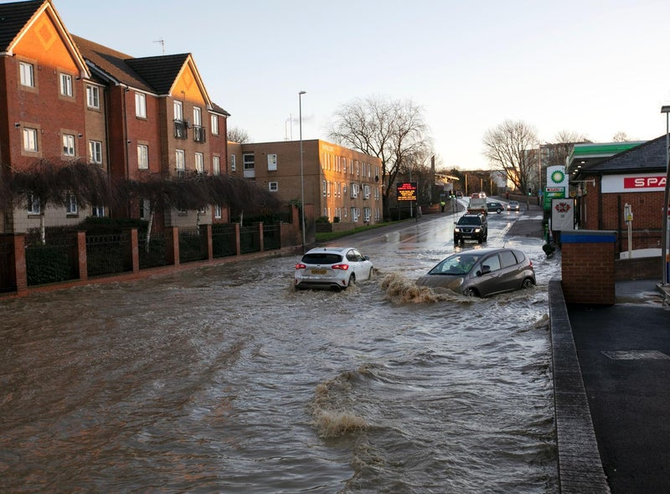

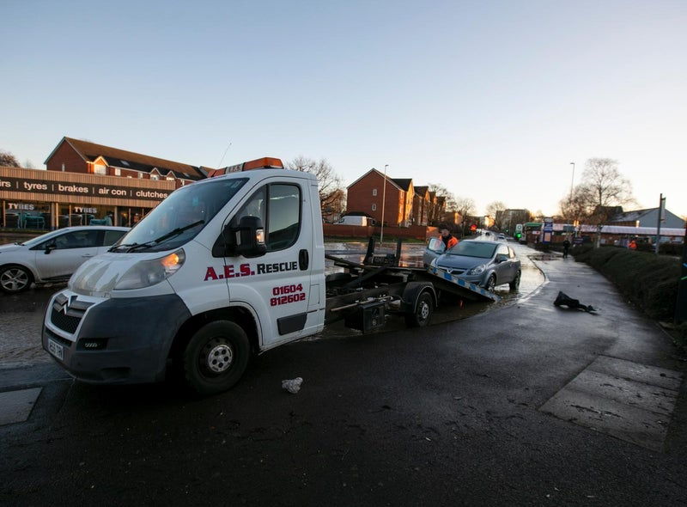

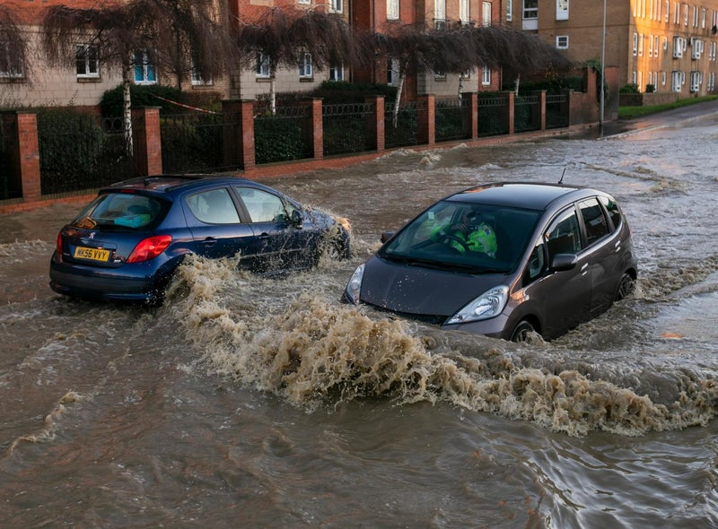

**Emergency services are in the process of evacuating more than 1,000 people from Billing Aquadrome** {in Northampton Urban Area} **as the waters in the area continue to rise following yesterday's heavy rain.**

## Old Mill Race

A river called Old Mill Race, quite a short one, runs along the outskirts of Weedon. Two river defences will have to be installed here, as it is very frequent for Old Mill Race to flood and would put the new Big Five supermarket and Weedon Riverside Primary School at risk of flooding, and possibly part of the High Street, depending on the severity, however, unlikely.

Weedon Bec’s flood plan can be found on the existing local council (Weedon Bec Parish Council) website, at [Microsoft Word - flood plan for WBPC Adopted July 15 (weedonbec-village.co.uk)](https://www.weedonbec-village.co.uk/uploads/flood-plan-for-wbpc-adpoted-july-15.pdf). This may have to be modified for Weedon Riverside to be approved.

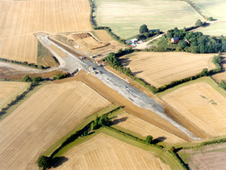

Now, the only flood defence that could be counted as one is a dam installed after a major 1998 flood in Weedon Bec.

## Location of defences



Three flood defences will be installed at Weedon Riverside, one on the River Nene, and two on Old Mill Race:

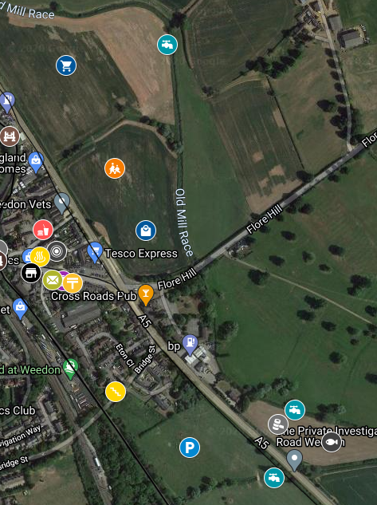

## Two new supermarkets

Currently, two general shops exist in the entirety of Weedon (Upper and Lower). A Tesco Express in Lower Weedon and a One Stop (also owned by Tesco plc) in Upper Weedon. This is not enough for the new Weedon Riverside new town to come into play, with its expected population boost with it. Therefore, we are proposing two new supermarkets on the outskirts of Weedon Riverside, one being a budget supermarket, and another being one of the Big Five supermarkets in the UK, catering to both audiences.

### Budget supermarket



This new budget supermarket will be built just South of the proposed new primary school and will be relatively small in size compared to other budget supermarkets in the area such as Aldi Daventry.

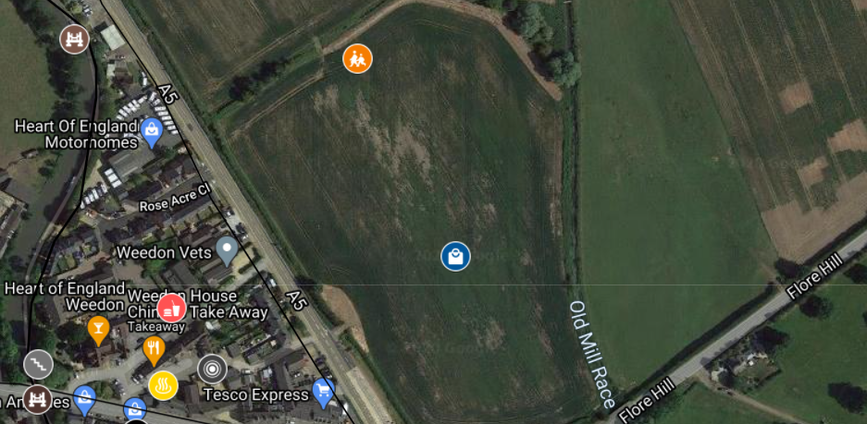

This new budget supermarket will be owned and operated by one of the following two companies:

* Lidl
* Aldi

Now, there are not many Lidl’s in the county, which could mean two things:

* Northamptonshire residents do not like Lidl
* Northamptonshire are in need of a new Lidl and might like it a lot.

However, there are countless Aldi’s in the county, such as Towcester and Daventry in the West. This could also mean two things:

* People in the county like Aldi a lot
* People in the county might be getting tired of Aldi and want a change.

### One of the Big Five



Now, moving onto the expected more popular supermarket. The standard, British supermarket, run by one of the Big Five, or two main hopeful operators.

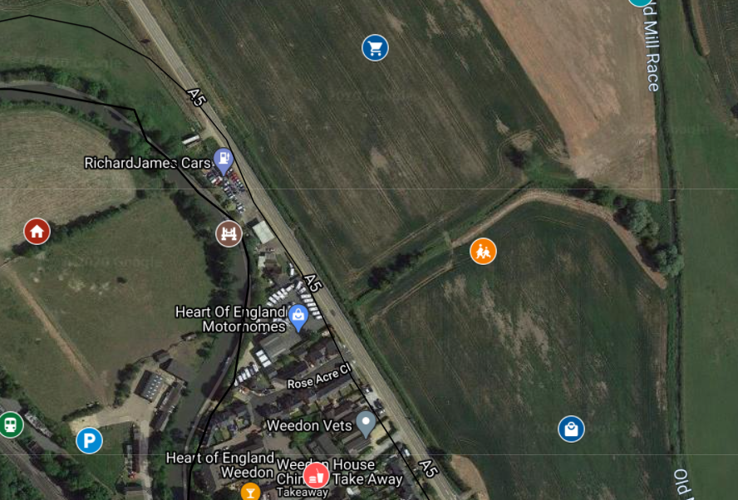

The one of the two companies we are hoping might operate it are Sainsbury’s plc and Morrison’s plc. Both companies would be a great addition to the area.

Sainsbury’s:

* More and more Sainsbury’s supermarkets are opening in Northants. It might be easy to convince Sainsbury’s to open one here.
* Argos stores normally exist in Sainsbury’s main supermarkets, and I could see a lot of people that live in Weedon Riverside using this Argos.

Morrison’s:

* There are only around 6-7 Morrison’s main superstores in Northamptonshire (so excluding petrol stations)
* But I know many people who go all the way to Northampton from places like Daventry and Weedon Bec, even, to do their Morrison’s shopping.
* Morrison’s would 100% succeed as this new supermarket operator, as there is a need for another in the county.

## New educational institution



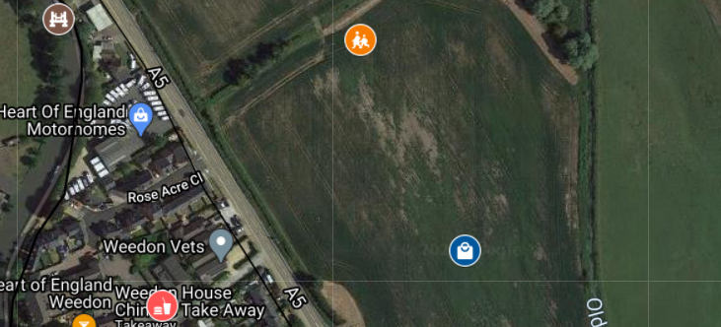

### Why

The primary school in Weedon Bec would not be able to handle the uptake in students after many new people move in to Weedon Riverside, and the residents of Weedon Bec do not want to see Weedon Bec Primary School expand even more. Therefore, a new Primary School, Weedon Riverside Primary School, just North of the new budget supermarket, will be constructed and put into action, handling the children of young commuters moving to the area.

### Safety



As Weedon Riverside will become a busy place, we want to ensure total safety. Therefore, a new bridge will be built across the canal and A5 to the top left of the screenshot, allowing safe walking to and from school to the two new commuter-focussed housing estates. Not visible in the photo is also another bridge going across the railway, linking Eastern Housing Estate, to Western Housing Estate, of course.

## Misc.

### Town hall



A town hall will be built to the South East of the town, near a new flood defence and food bank, right opposite the new mini retail park and Southern car park.

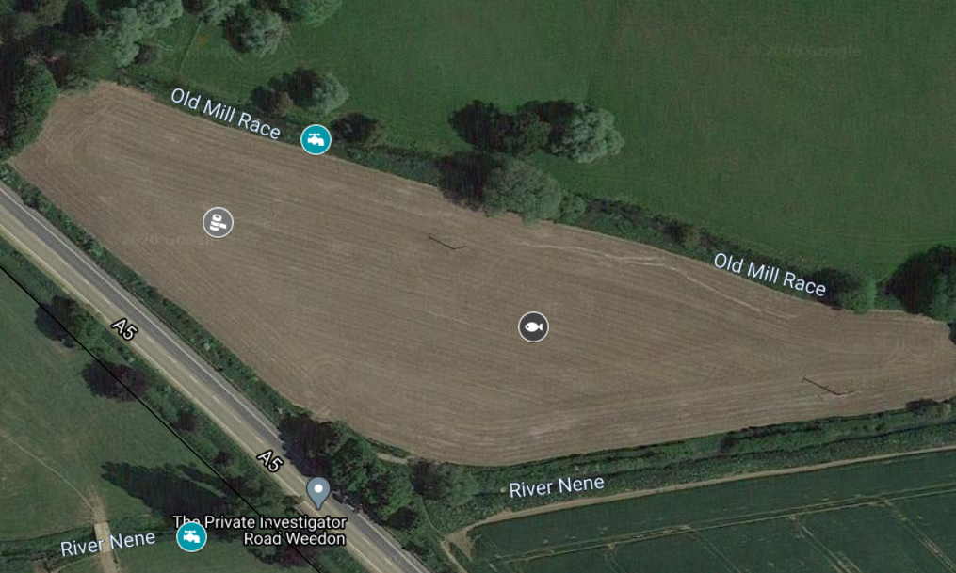

This place will be used by the new Weedon Riverside Community Council for general meetings, and will be able to be hired out for parties, celebrations, business meetings etc.

### Food bank



Just a few yards to the East of the new Town Hall is a food bank, a new location for the Weedon Bec food bank, if they would like to relocate their stocks from the village church and existing Primary School.



The food bank will be relatively combined with the Town Hall, allowing people to drop donations off/collect food from the Community Council at the Town Hall.

The next two proposed buildings and services will be built after a population boost is seen in Weedon Riverside, as, now, these services are not required

### Police station/fire station combination



A combined police station/fire station will more than likely be required after a population boost in the town, due to extra calls and of course, fires and emergencies which always come due to a higher population.

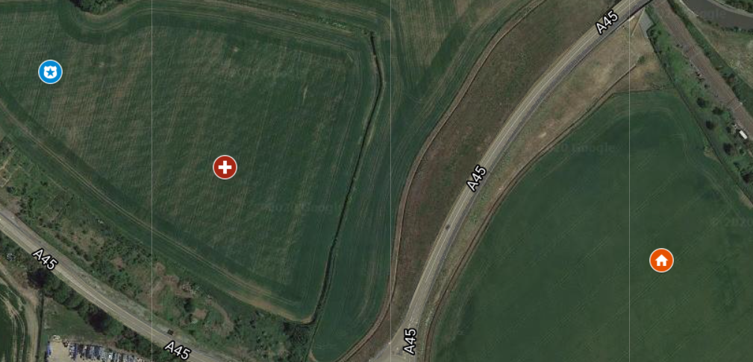

### Doctors surgery



A GP practise already exists in Weedon Bec village, however, a second branch, possibly owned by the same company, may have to open in Weedon Riverside due to the population boost and new registrations as a patient, leading to more demand for appointments, needing more space.



The doctor's surgery will be just to the East of the police station/fire station, which is quite convenient, and to the West of the new Western housing.

## Relocating businesses

### On the high street

Quite a few businesses on the high street, around 2 on the main road, and 5 on the proposed Town Centre area will have to be relocated (businesses on the town centre will remain in the town centre, just in alternative buildings to mix with the surroundings)

### Relocating where?

#### New mini retail park:

The new mini retail park to the South of Weedon Riverside will do quite well to fit in businesses that are forced to relocate and has more than enough space to fit them all, even those that want to move just to get out of the new hustle and bustle of the High Street.

#### Depot:

The depot in Weedon Bec, as I said, we have no comments on, but is being developed at a rapid rate, and will certainly be able to fit in the new businesses that are moved from the High Street, and they can expect a similar amount of business too.

#### Town Centre:

Town Centre will not be able to fit many businesses, after all the existing ones are put into different buildings in the same location, and two new businesses are formed.

#### Weedon Riverside Station:

We are hoping for space at Riverside station to implement around two retail spaces and two coffee shop type spaces at the station, as well as a ticket office (Sustainable Transport Northamptonshire’s responsibility).

# 4. Just a concept

## Could be approved, could not

This plan is not an official Department for Housing plan, it is not set-in stone it’ll happen. It is just a concept. For those that love Weedon how it is now, you shall not worry, this document is a concept of *what* the future *could* look like.

## Businesses shall not worry

This could be approved; this could not be approved. But either way, you, local businesses, do not have to worry. If it is not approved, or even shown to the Government, then you have no reason to worry whatsoever, everything will stay the same for you. If it is approved, then we and the local councils and the Department for Housing will do our best to help you with the changes, such as relocating to a new place.

# 5. Positives of this plan

## Increasing population

The population will clearly receive a massive boost if the project is approved by Central Government and the local council. So many things can tempt people to Weedon Riverside, including its amazing rail links, and educational institutions, proximity to local general shops, and an incredible high street. Especially the young population working in London or Birmingham and want a peaceful home to come back to. This is the perfect place for those sorts of people.

## Boosting the economy

The economy will also be boosted by this plan, for example, not only Weedon Riverside residents will use the new station, but also people who live in Daventry, for example, will travel to Weedon Riverside station to take a train, but while here, might take a wander down the High Street and buy some food, or have a meal, or buy a new decoration for home, for example.

## Another town in Northants (we do not have many)

There are 17 towns in Northamptonshire, and only 4 of them are in West Northamptonshire, compared to 47 total towns in Kent, this is miniscule, and only one town existed in the Daventry District before it was dissolved, Daventry! Weedon Riverside will give West Northants that extra town, and not only an extra town, but an extra boost to the economy and the local population, being one of the largest towns in West Northants.

## Transport links for Daventry

As I said in “Boosting the economy”, this plan will also enable Daventry residents to use rail more, with it only being a 5-minute drive to the new station, and just a 20-minute bike ride, and bus services to the station being frequent and good quality, to the new Weedon Riverside bus station.

# 6. Problems with this plan

## Residents might not like it

People who live in Weedon to enjoy the ruralness of it all probably will not particularly like this new plan, however, one of the reasons we are not touching Weedon Bec is due to the residents “liking it how it is” you could say, and this is because Weedon Bec is a rural, quiet, and calming village.

## Leaving Weedon Bec alone

This brings me on well to my second point, some people in Weedon prefer being rural, as Northamptonshire is a primarily rural county, and some people choose to settle in Weedon Bec to get a good mix of ruralness and civilisation. Within the Weedon Riverside area, it will be more urbanised and civilised, becoming more like a small to medium sized town, sort of the size of Raunds, just with a higher population.

## Traffic congestion

With more people driving into the town, for many reasons, including to go home, or go shopping, or tourists, it will increase traffic congestion at Weedon Riverside. However, we will be encouraging sustainable transport to the town, such as rail, electric bus, and scooter, and bike.